`DIS- Asia-China- Numismatics-Knives

The first monetary knives of antique China, called "sharp knives", *jianshou dao*, came from the knives of the hunters and shepherds of the North of China. Indispensable instrument for the agricultural and pastoral life, for the nomads and the breeders, the knife became an exchange object, general equivalent for all the populations of the North, Xiongnu, Ordos, Rong, Di and Oof. Gradually, by the 7-th century BC, the monetary knife lost any practical use, to become only a monetary sign. The monetary sharp knives are produced mainly in Yan's realm and in nomadic confederacies of Rong and Di located in the North and in the northeast of China.

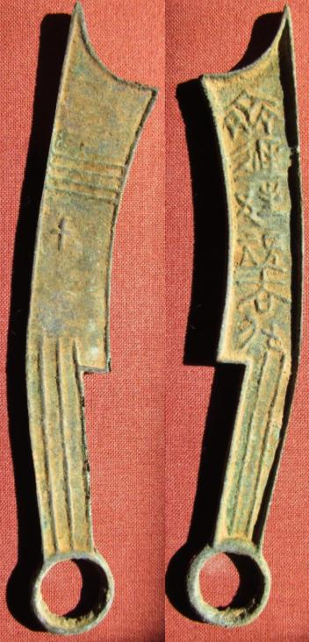

A sharp knife of Yan or the nomadic Rong or Di (6th-5th century BCE)

SHAPE \\* MERGEFORMAT 